AAUW – East Mesa Branch
Has granted nearly a Quarter Million $ in Scholarships in 2019!

AAUW East Mesa branch distributed $230,000 in scholarship money this year, both for local scholars ($104,000) and a national named Fellowship ($120,000), along with a grant to Mesa Public Schools for the STEM Odyssey Space Integration Module (SIM) for $6,000.

We think this is a big deal for our community!

Over 30 years, the hard-working, dedicated members of this American Association of University Women (AAUW) branch have raised $214,000 for 175 local scholars and a national Fellowship of $120,000 through various fundraisers from fashion shows, garage sales, direct donations, and an annual Scholarship Author Luncheon.

In 2016 we received a windfall endowment from our founder and first branch president Dr. Violet H. Larney, who left 44% of her estate when she passed away to the AAUW East Mesa branch. The earnings on those endowed funds are designated for a perpetual fund for scholarships, fellowships, and other AAUW charitable activities. and are the reason we were able to make such great contributions this year. Our members have worked with diligence to provide scholars with financial aid. Violet’s legacy has provided the “icing on the cake” for our scholars.

In addition to raising funds and vetting the applications for those scholarships, each local recipient has an AAUW member who serves as her mentor to provide advice and support throughout the duration of her award. Some of the recipients are just beginning their college experience while others receive support further along in their college experience.

AAUW leads the nation in advocacy for women, especially in the areas of pay equity, leadership, empowerment, education and training.

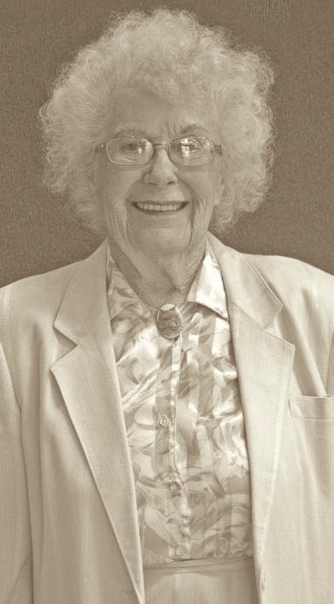Dr. Violet H. Larney, 1920-2016.

